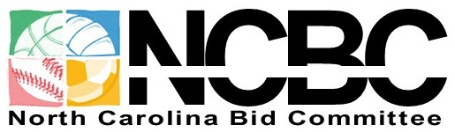
FOR IMMEDIATE RELEASE
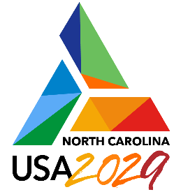
January 10, 2023

Media Contacts:
Cyrus Stewart, Fitzpatrick Communications, 919.696.2928,
cystewart@fitzpatrickcomm.com

Hill Carrow, Chairman & CEO. North Carolina Bid Committee
919.678.1651, hcarrow@ncwug2027bid.com

NORTH CAROLINA USA LANDS 2029 FISU WORLD UNIVERSITY GAMES
Lake Placid, New York: The Executive Committee of the International University Sports Federation (FISU) voted today to confirm the selection of North Carolina USA as Host of the 2029 FISU World University Games. The FISU Executive Committee is meeting in Lake Placid prior to the start of the 2023 FISU World University Games Winter taking place in Lake Placid and the Adirondack region, from January 12 to 22, 2023 – the first time the FISU Games Winter have been held in the United States in 51 years. Lake Placid was the previous host in 1972.
Leonz Eder, President of FISU, said, “We were very impressed with what North Carolina has to offer the FISU Games from our site visits, their candidature dossiers, and the presentation to our Executive Committee. The North Carolina USA Bid, in fact, scored the highest on our staff technical evaluation. With our leadership gathered in Lake Placid today for start of the Winter World University Games, the timing has been very appropriate and opportune to approve North Carolina USA as the Host City of the 2029 FISU World University Games.”
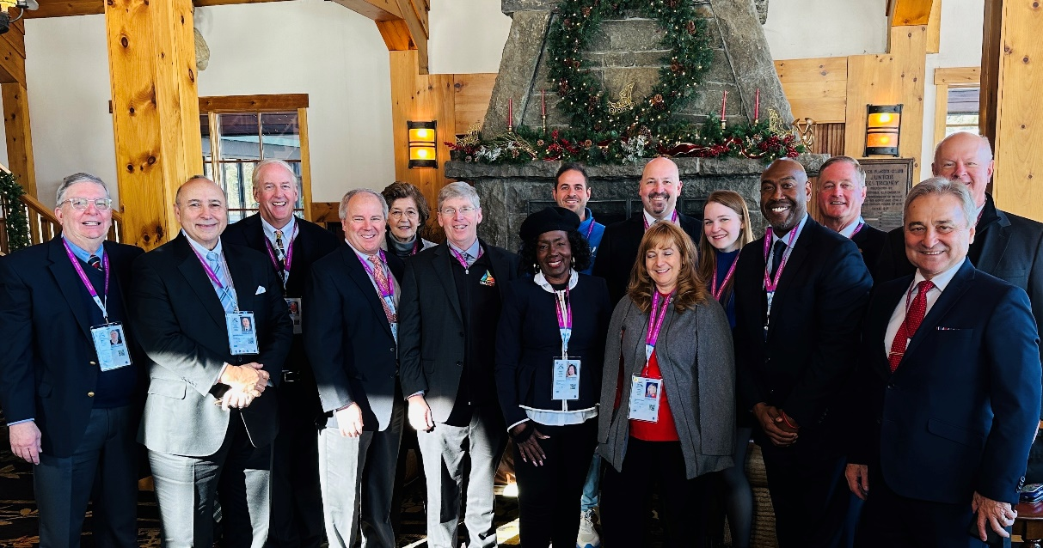
The North Carolina USA Delegation in Lake Placid for the Award of the 2029 FISU Games
North Carolina USA had a significant delegation in Lake Placid attending the FISU Executive Committee Meeting and Signing Ceremony including Elaine Marshall, North Carolina Secretary of State; Brenda Howerton, Chairman of the Durham County Board of Commissioners; Brian Ralph, President of William Peace University; Richard Beard, President & CEO of the Greensboro Sports Foundation, and Dragomir Cioroslan, Director of International Strategies and Development at the United States Olympic & Paralympic Committee. Secretary Marshall, representing the State of North Carolina, had this to say, “This is a very proud moment in our State’s history. The FISU World University Games will be the largest event ever hosted in our state, and it will give us the unique opportunity to not only host athletes and fans from more than 150 countries, but to showcase North Carolina, including our renowned universities and all that our great State has to offer, to a worldwide audience of more than 400 million!”
The FISU World University Games are the largest event for student athletes on the planet and second in size only to the Olympic Games in terms of global Olympic multi-sport competitions. FISU conducts both a winter edition and a summer edition every other year in the odd year. The FISU World University Games Summer have only been held once previously in the United States, in 1993 in Buffalo, New York. The Chengdu 2021 FISU World University Games in China, will feature more than 7,000 athletes competing in 18 sports over a 12-day period. North Carolina’s Bid to host the FISU World University Games is centered in central North Carolina, in a region stretching from Raleigh to Greensboro, encompassing the Triangle and Triad areas of the state. The region includes 19 colleges and universities with more than 250,000 university students and has been branded as North Carolina’s University Hub.
On behalf of the United States International University Sports Federation (USIUSF), the U.S. member of FISU, Dan Guerrero, USIUSF President, said “This is a milestone in university sports history in the United States. Building off the excitement of the FISU World University Games Winter that start here in Lake Placid this week, the 2029 FISU World University Games Summer in North Carolina will take the presence and awareness of international university sports in the United States of America, the number one market in the world for collegiate sports, to the next level!”
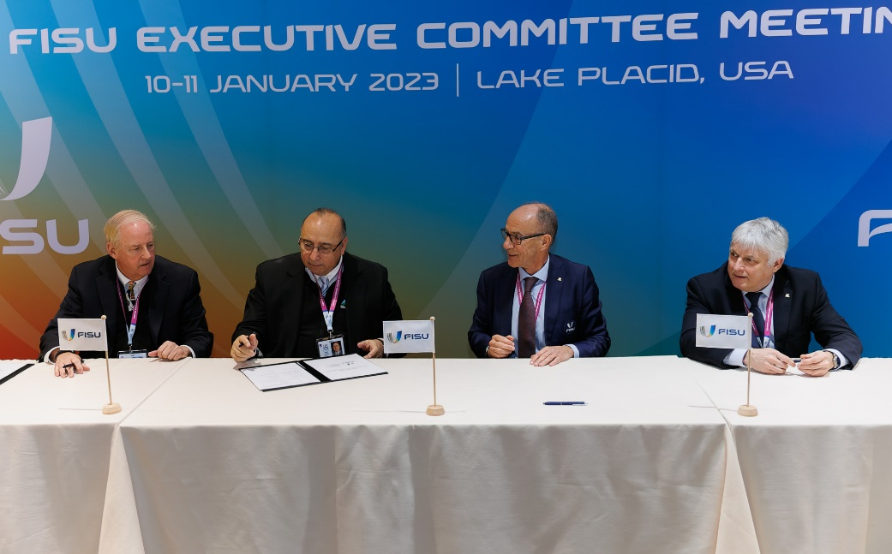
The Contract Signing Ceremony in Lake Placid, NY, at the FISU Executive
Committee Meeting, Jan. 10, 2023. Left to right: Hill Carrow (NC Bid Committee
Chair & CEO), Dan Guerrero, Leonz Eder, and Eric Saintrond (FISU CEO).

Accepting the award of the FISU Games on behalf of North Carolina was Hill Carrow, Chairman & CEO of the North Carolina Bid Committee. “The award of the 2029 FISU World University Games to our state and country is the culmination of an extensive 5-year effort by more than 1,000 individuals, 13 universities, 5 cities, 5 counties, the State of North Carolina, and 53 corporate and organizational sponsors to land this amazing event. As an event that features the best collegiate athletes from around the world, it is a natural fit for a state with 130 colleges and universities and more than 350,000 university students. North Carolina’s landing these Games is similar to a major corporate relocation as the FISU Games will deliver a local economic impact of over $150 million, but with the added benefits of significant international tourism and worldwide branding exposure for our state and local communities. We thank FISU for selecting North Carolina USA as the Official Host of the 2029 FISU World University Games, and we look forward to partnering with the FISU Family to deliver a most successful 2029 Games!”
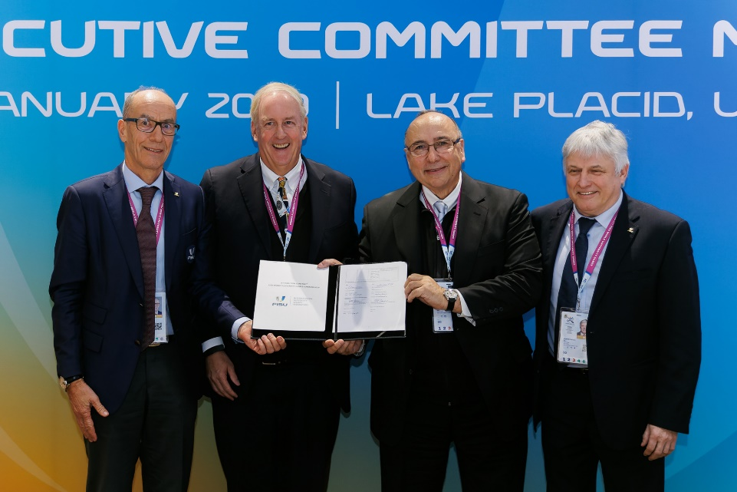
Pictured Above: Leonz Eder (left), Hill Carrow, Dan Guerrero, and
Eric Saintrond, with the 2029 World University Games Contract

About the North Carolina Bid Committee: Centered in the heart of North Carolina, the North Carolina Bid Committee is comprised of individuals who have been helping with, supporting, and leading an initiative to recruit and host the FISU World University Games in the Raleigh-Durham-Chapel Hill-Cary-Greensboro region of North Carolina. The NCBC is affiliated with, and supported by, the Triangle Sports Commission, which primarily serves Wake, Durham, and Orange Counties, but also hosts events in Guilford and Alamance Counties in North Carolina. The primary goals of the NCBC are to host one of the best World University Games ever, with a great participant experience being the primary barometer; and to showcase North Carolina, and the communities and universities that comprise its central University Hub region, to the world. GAMES HOSTS: Host Country – United States; Host State – North Carolina; Host Cities – Raleigh, Durham, Chapel Hill, Cary, and Greensboro, NC; Host Counties – Wake, Durham, Orange, Alamance, and Guilford Counties; Host Institutions (as of 1/10/23): Duke University, Durham Technical Community College, Elon University, Meredith College, North Carolina A&T State University, North Carolina Central University, North Carolina State University, Shaw University, St. Augustine’s University, University of North Carolina Chapel Hill, University of North Carolina Greensboro, Wake Technical Community College, and William Peace University. BID SPONSORS: North Carolina’s bid is currently sponsored by 53 corporations and organizations including the Angus Barn, Atlantic Tire & Service, the Bell Koonce Burnette Foundation, Brasfield & Gorrie, the Joseph M. Bryan Foundation, Calvert Sports Foundation, Capitol Broadcasting Company, CapTrust, Cary Chamber of Commerce, CBRE, Coastal Credit Union, Cone Health, Duke Energy, Duke Health, East West Partners, Edge Printed Products, First Bank, Fitzpatrick Communications, Greensboro Convention & Visitors Bureau, Greensboro Sports Council, Greensboro Sports Foundation, Guilford Merchants Association, Hannah Sheridan & Cochran Law Firm, Hummingbird Creative Group, Kilpatrick Townsend, Koury Corporation, Laser Image Printing Marketing, Longleaf Law Partners, Martin Marietta, McDonald York Building Company, NAI Tri Properties, North Carolina FC & the NC Courage, PNC Bank, the Preiss Companies, Preston Development Company, Raleigh Orthopaedic, Raleigh Regional Association of Realtors, Sports & Properties, Inc., Stewart, Tego Data, The Cemala Foundation, The Special Event Company, Transcend Commercial, Triangle Badminton & Table Tennis, Triangle eSports Academy, Triangle Sports Commission, Truist Bank, UNC Health, Wake Competition Center, WakeMed, the W. Trent Ragland Jr. Foundation, Wasserman, and York Properties, Inc. For more information on the North Carolina Bid Committee or to make a donation to support the bid committee, visit www.ncwug2027bid.com.
About the FISU World University Games: The FISU World University Games are the world’s largest event for student athletes, ages 18-25. The rightsholder for the FISU Games is the International University Sports Federation (FISU), based in Lausanne, Switzerland. The U.S. member of FISU is the United States International University Sports Federation (USIUSF), located in Orlando, Florida. The World University Games got their formal start with the 1959 Games in Torino, Italy, where 985 athletes from 45 countries competed in 7 sports during a 12-day period. In more recent times, Taipei 2017 for example, 7,377 athletes from 134 countries competed over 13 days in 275 competitive events in 22 sports at 60 venues where 1,957 medals were awarded. The 15 required sports of the FISU World University Games Summer are Archery, Artistic Gymnastics, Athletics (Track & Field), Badminton, Basketball, Diving, Fencing, Judo, Rhythmic Gymnastics, Swimming, Table Tennis, Taekwondo, Tennis, Volleyball, and Water Polo. For the 2029 FISU Games, the NCBC has proposed Baseball, Rugby 7s, and Softball as the “local option” sports. Upcoming editions of the FISU World University Games include the 2023 winter edition in Lake Placid, NY, USA (January 12-22, 2023); Chengdu 2021 FISU World University Games Summer in China (July 28-August 8, 2023); Torino 2025 FISU World University Games Winter in Italy (January 13-25, 2025); Rhine-Ruhr 2025 FISU World University Games Summer in Germany (July 16-27, 2025); Chungcheong 2027 FISU World University Games Summer in South Korea; and the North Carolina 2029 FISU World University Games Summer in the USA. For more information about the FISU World University Games, FISU, and World University Championships, visit www.fisu.net.

